Magic Biography: Kai Budde
Gary Wise
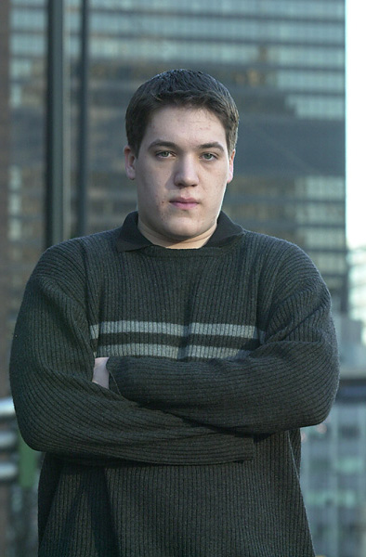
Before Pro Tour Chicago, Kai Budde was in a slump. Following his win at World Championships '99 with a Top 16 in London, his performance level then dropped abysmally. Where at one point, people were mentioning his name in the same sentence as Jon Finkel's, now players were questioning whether he'd ever been that good at all. In Chicago he silenced his critics.
An avid football (that's soccer to you American types) fan and son of a Computer Scientist and College Professor, Kai had already etched his name in the Magic history books, but Chicago ensured that as long as there was Magic, Kai Budde's name would be remembered. Previously a World Champion and Player of the Year, Kai's victory in Chicago, his second at the PT level, lifted him to the 2-PT-win plateau shared by only two other players, Tommi Hovi and the aforementioned Finkeltron. Kai was now immortal.
Like last week's subject Ben Rubin, Kai started out very young in Magic, starting through the junior ranks and eventually making his way to the Tour through initial successes there. There have been peaks and valleys along the way, but now, sitting third in the Player of the Year rankings with a fresh PT win on his resume, Kai is back in form. What follows is his story.
Individual PTs
Mainz 98 - 52nd
Chicago 99 - 19th
Rome 99 - 126th
LA 99 - 51st
NY 99 - 27th
Worlds 99 - 1st
London 00 - 11th
Chicago 00 - 51st
LA 00 - 98th
NY 00 - 42nd
Worlds 00 - 120th
Chicago 01 - 1st
LA 01 - 25th
Teams PTs
DC 00 - 10th
NY 01 - 22nd
GPs
Birmingham 98 - 2nd
Barcelona 99 - 1st
Vienna 99 - 1st
Amsterdam 99 - 1st
Florence 00 - 3rd
Kai, who is known to all German Magic players as Karl, first got into gaming in the summer of 1995, when he did a little role-playing. It was during one such session when friends of his showed the 14-year old the latest thing, this card game with D&D-like characters called Magic: the Gathering. Kai quickly started learning the ins and outs of the game, and before the summer was over, found his way to a local store in his home of Cologne, Germany. It was there he'd make his first contacts in the game.
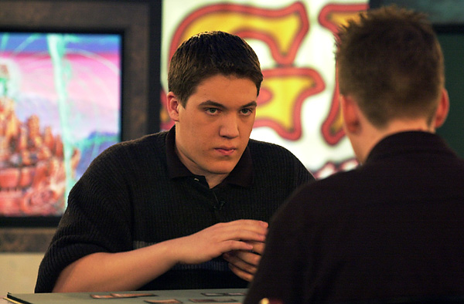
While those school friends stopped playing soon after, Kai was hooked. He started going to the store regularly where he'd spend time with top German tournament players. Among them were PT Atlanta winner Frank Adler, Markus Bell (who recently finished 12th at PT Chicago), Thomas Esser and former PT participants Jan Brandenberg and Tim Gloekner. These players comprised what many felt was the finest team in Germany at the time.
It was from these men that Kai really started to learn the fundamentals of the game. Learning by trial and error, Kai lost more than he won, learning from his mistakes as he moved along. His first deck was a Necro deck ("long before Necro summer") featuring his favorite card, Nightmare. He especially enjoyed the combination of Nightmare and Thawing Glaciers that helped him in the mirror match. It was this deck Kai took to his first tournament, where he went 4-2 and fell in love with tournament play.
Around that time, an event outside Kai's life would have major ramifications on his involvement in the game. Back from school in Atlanta, Dirk Baberowski, an avid player, moved to Cologne, and as most players would, proceeded to search out his local gaming establishment. It was there that he and Kai met for the first time: "I moved to Cologne in late '96 and went to the local gaming places and that's where I first met Kai, although he was far from being the top player there. I guess Kai and I were both second tier players at the time."
Within a year, Kai and Dirk had hit it off and were playing on the PTQ circuit. With no Junior PTQs in Germany at the time, Kai was forced to play in the adult qualifiers, but to even his surprise, he found himself winning his second Limited PTQ, qualifying him for New York. Upon his arrival, it was pointed out that because of his age, Kai was eligible to play in the Juniors, so, despite the fact that German university is paid for by the state, Kai decided that his chances of success would be better in the younger ranks and decided to try taking the game's best Juniors down.

'Se problem is: Wat se Karl plays kan only play se Karl' 'don't pick the deck that Kai picks. Only he can play it.' - Felix 'Flix-' Schneiders, German semi-pro.
It was then that Kai found himself more than capable of competing. Winning his first table 4-0 (defeating Jamie Parke and Brian Kibler along the way), Kai finished in the Top 16 of what was to be the final Junior Pro Tour. Unable to afford a flight to Chicago, Kai arranged to have his invitation deferred to the Tour's next stop, in Mainz, Germany.
With newfound confidence, Kai felt he was finally ready for the big time. Starting Mainz 4-1-1, Kai made it to Day 2, where the youngster found himself a little overwhelmed. Finishing 52nd, Kai fell off the Tour and started reprioritizing, with competitive Magic taking a back seat to school and family. For the next year, Kai sat at home as the Worlds finest gathered for Tour after Tour, unable to qualify.
Then, lightning struck. Traveling with his mother to Hamburg, Kai found himself escaping for a day to play in a PTQ for PT Chicago 2. Kai's efforts were rewarded, with his 'god deck' enabling him to make Top 8 without a single duel loss. Once in the Top 8, Kai swept through the remaining opposition and he was once again qualified.
Fortunately, Dirk had also made it to Chicago 2 for his first PT, and while the two entered the tournament anything but confident, they both quickly found that they had been overrating the opposition, or, more importantly, underrating themselves. Dirk went on to win the tournament while Kai came 19th. After that, it was off to GP Birmingham, where the now-confident German finished second, and Kai was on a streak that few would ever match.
Over the next six months, Kai tore through the opposition in a way that no one had ever seen. He won his next GP in Barcelona. He won a second GP in Vienna a month after that. Two months later, he won a record third GP, this time in Amsterdam. In all, he collected 23 Pro Tour points in four GPs over six months. That he was now qualifying for each PT was nice, but those points would soon prove more useful than even he realized.
After a disappointing performance playing Necro in Rome, Kai checked into the first two PTs of 1999 in solid fashion, with a 51st place finish in LA and a 27th place finish in New York. This left him with 43 Pro Tour points on the season going into World Championships. It would be just enough.

"The scary thing about Kai is that he is still getting better. he is a better listener now and he will not let first impressions of a deck over cloud his judgment anymore - I think that is a simple reflection of his maturity." - Ben Ronaldson
Working with Baberowski, Hamburg's Marco Blume, Cologne's Andre Konstanzer and the rest of the qualified Germans, Kai went to Tokyo confident of a strong performance to come. Kai started off the tournament well enough with a 4-2 record in Standard using the same Wildfire deck Blume would play in the team final, and added to that a 4-1-1 record in Limited play on Day 2. This said, it was on Day 3 where he really shone. Kai started the day 4-0, affording himself the option of drawing into Top 8, his first on PT.
With his GP success over the year Kai was suddenly in one of the most pressured situations in PT history. Not only was he vying for a World Championship, now in contention for Pro Tour Player of the Year, he needed a semi-final victory to pass frontrunner Darwin Kastle. After dispatching of Jamie Parke in the quarter final, Kai was paired up with Raphaele Lo Moro's Stompy deck. With Kastle watching on, Lo Moro would come quickly out of the gate, only to find Kai's Wildfires, Masticores and Cursed Scrolls waiting. The Italian didn't stand a chance.
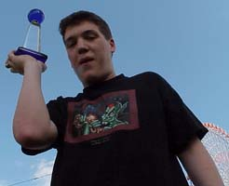
Kai at the World Championships
With the Player of the Year title wrapped around his waist, Kai proceeded to absolutely smash Mark LePine in the final. Playing what Kai recalls as his favorite match of Magic, in the final game, Kai played a Covetous Dragon on turn 2 followed by a Masticore on turn three. When LePine attacked, laughing, with his Ghitu Encampment on his following turn, Kai knew he'd captured the game's most elusive prize: a World Championship.
With his twin titles in tow, Kai, the only player to win both in a single year, kept right on rolling. His next major event was PT London, where his 11th place finish was a good start to the new season, but while Kai's personal record started going downhill from there, he was developing some very important connections. In Chicago, while Kai's successor for Player of the Year, Bob Maher, was winning the Pro Tour, Warren Marsh, part of the English effort to create Cocoa Pebbles, approached Kai on the possibility of working together for future Pro Tours. Marsh, who had worked with Tony Dobson, John Ormerod, Scott Wills and Ben Ronaldson in the past, also talked to Stephan Valkeyser, Baberowski, Mattias Jorstedt, Svend Geertsen and other well known European players, and a team was formed.
Dubbed the European Alliance, the group almost immediately started testing for the next Constructed Pro Tour, NY, where Invasion Block constructed would be the order of the day. With a disappointing 98th place finish in LA 2000, Kai became more determined than ever to have a strong showing in NY.
Kai's efforts were rewarded. Finishing a respectable 42nd, his teammates did him one better. Playing two Rebel variants, Marsh finished second playing the same version as Kai, while EA contributors Mattias Kettil and John Larkin both made Top 8. Larkin was a force during the Swiss rounds, leading the tournament for most of the second day. In the end, debates raged as to which of EA, Mogg Squad or Jumble had the best tournament, but it was universally agreed that the Alliance was for real.
At World Championships in Belgium, Kai had his worst tournament finish in almost two years, finishing 120th. Co-designing the deck Dominik Hothow played into Top 8 with Baberowski and me, Gary Wise, of Mogg Squad, Kai himself had a poor tournament that started him on the roughest half year of his professional career. While his Team Juggernaut (also consisting of Baberowski and Andre Konstanzer) finished a respectable 22nd at NY, it had to be considered a disappointment for a team that finished 10th the year before. Kai also got what many felt was the best possible pairing in the first round of the Masters in New York, only to lose to Jason Zila, who'd been out of the professional game for two years. Additionally, the one time master of the European Grand Prix failed to make the cut to second day of four consecutive GPs. Finally though, he broke out of his rut on the second day of his second Invitational of the year.
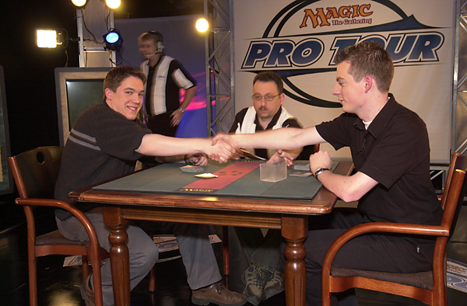
Kai's Invitational started horribly. Going 0-5 on Day 1, Kai stretched out his string to eight losses before finally defeating Yoshikazu Ishii in Solomon draft. Kai then started winning... and winning... and winning. He finished the Invitational with seven straight wins, giving him the shot of adrenaline he desperately needed. Going to GP Florence the next weekend, Kai braved a field of over 600 competitors to finish third with the Trix deck that he'd designed with the newly slimmed down roster of the European Alliance. Teammate Ben Ronaldson lost in the other semifinal in the tournament that has to be deemed Kai's return. A week later, with the EA Rebel deck in tow, he headed to Chicago.
For Kai, Chicago worked out like a dream. Starting the tournament 6-1, Kai worked his way to 31 points and a six-way tie for 1st after the 13th round. With the worst tiebreakers of the six, Kai decided he had to play. His opponent was to be Arto Hiltunen of Finland, with whom the EA had a history. Playing against Ben Ronaldson at GP Helsinki, Hiltunen was involved in an incident which made the normally calm Ronaldson angry enough that he left the table, conceding the match, rather than sit with the Finn. It was Budde's job to gain Ronaldson's revenge. Kai did so, winning the match in three games. Once in the Top 8, Kai, beat Jay Elarar, then Brian Kibler, and finally Kamiel Cornelissen to take the title, his second in two Top 8 finishes.
Kai followed up his Chicago win with a very respectable 25th place finish in LA. Third in the player of the Year race, Kai, now living in Hamburg, is working with Patrick Mello, the English players and Kobra Kai (Scott Johns, Zvi Mowshowitz and Brian Selden) towards success in Tokyo. Having taken off his first semester from school, Kai is more or less full time, though he does plan on getting back to school to ensure his future should the Pro Tour not always be an option.
For now though, Kai is first and foremost a PT player. Will the confident and straightforward Budde be able to follow up his early success this season? Could he become the first two-time Player of the Year? Only time will tell, but if the past teaches us anything, its that Kai will always be prepared to take his beatings, and use what he learns to rise to victory once again. PT players, consider yourselves warned.

